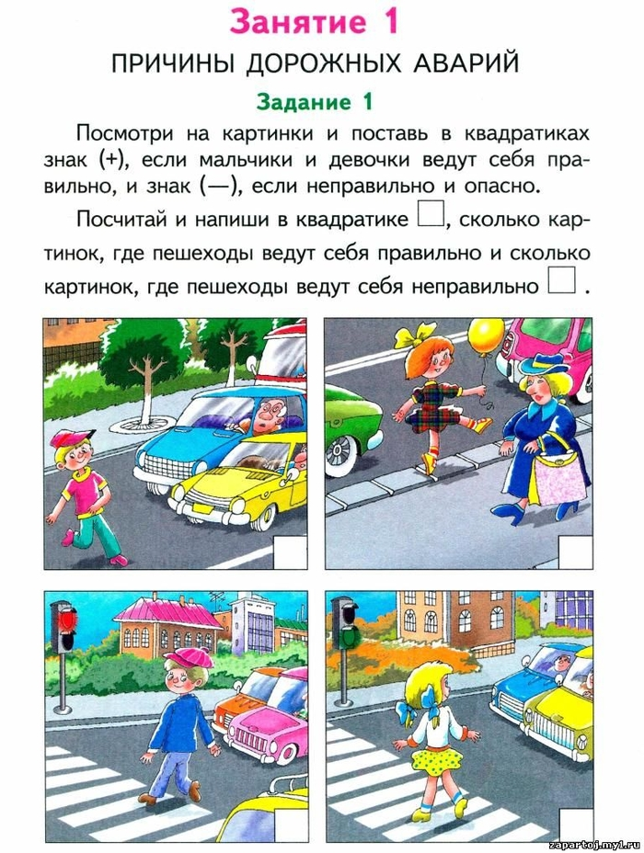
ДОУ:_____________________________________________________________

