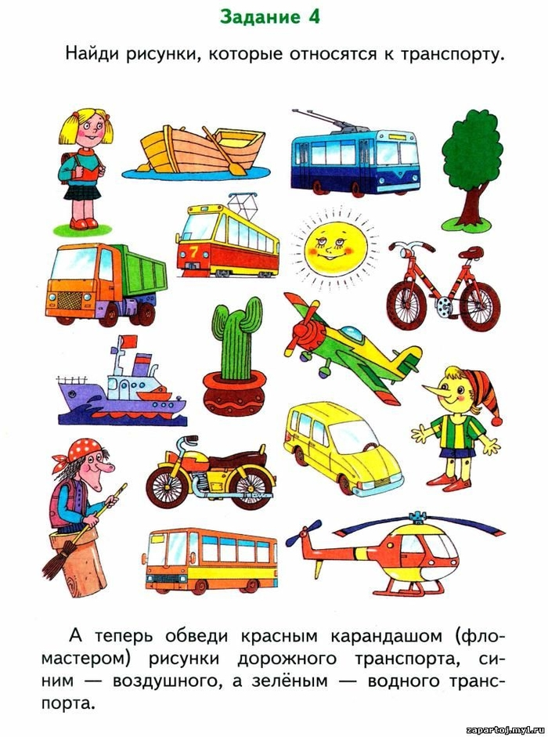
ДОУ_________________________________________________________________________________

